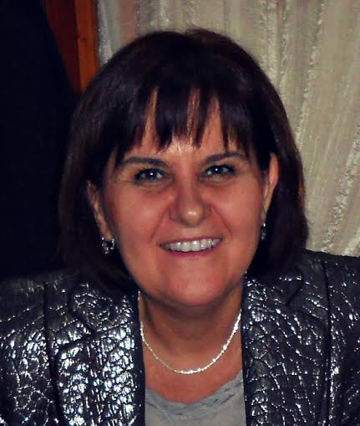

Prof. dr Gordana Budimir Ninkovic is a full professor at the Faculty of Education in Jagodina, University of Kragujevac. She teaches the following academic courses: Introduction to Pedagogy, School and family pedagogy, Pedagogy of the free time, Pedagogical communication, and Pedagogical phenomenology. She has published dozens of books and scientific papers in the national and international journals in the area of Pedagogy and relevant sciences. She participates in several national and international scientific research projects. Furthermore, she is included into the realisation of numerous research activities in the process of promoting pedagogical theory and practice in the country and abroad.

